PROJECT REPORT
(Till 24th November 2011)

PROJECT NAME

MARBLE MAZE

GUIDE NAME

PAWANKUMAR SURYAWANSHI

GROUP MEMBERS
GHARAT APURVA
KULKARNI JYOTI
PATIL SUPRIYA

KOKAN GYANPEETH COLLEAGE OF ENGG.,KARJAT.

INTRODUCTION
Marble maze is a game in which you need to control a ball in a labyrinth by titling the device in your hands and leads the ball into goal.
Game is actually based on the classic game that many of us have played when we were little children where tiny ball have to make its way around the obstacles, through the maze, reaching the goal.
Our aim is to create an exciting game for all age groups.
To achieve the aim, our objective is to study the working of sensors, microcontrollers, MATLAB, and to learn the Embedded Systems.
This project can be used as an exciting game in entertainment industry. Following can be the places where the game can be used on commercial basis:-
- Gaming zones
- Shopping malls
- Airports
- Multiplexes

The similar types of games are available in the market but there is no choice given to the player. The player has to play the game either any of two options which we are trying to combine in a single game.
As said above the existing system does not contain option to the user. So this will differ our project from existing system as we will be providing choice to the user.

PROBLEM STATEMENT
Marble Maze is a board puzzle where the goal is to make a marble traverse through a maze from start to the end point. This project aims at robotically controlling this traversing motion of the marble from a defined starting point to the ending point. This can be achieved using:
  - Image Processing System (Computer Controlled) or
  - Accelerometer (Person Controlled)
Player will be given two choices at the start of the game. If the player selects Image processing then there will not be any manual interaction between the game and player. Player can enjoy the solving of puzzle as any person enjoys the game of Cricket just watching it, though he or she is not actually playing the game.
If the player selects Accelerometer then user will interact with the game through the accelerometer. It is the same device which is used n mobile phones to play some mobile based games. As the user will move the accelerometer the maze will be moved accordingly and user himself will solve the puzzle.

Image Processing:
This task involves using an overhead webcam to process the image of the marble in real time and mapping its motion against a pre-designed maze in the computer. This is a computer controlled method to make the marble reach its destination point. In this, the webcam will feed the motion of the marble in a computer. Using pre-designed algorithms, the computer will move the board such that the marble traverses through the maze taking the most optimized route to its destination.

Accelerometer:
This device will measure the acceleration of the marble during its motion across a frame of reference, which in this case is, the maze. This is a manually controlled method to make the marble reach its destination point.

HARDWARE REQUIREMENTS
- ATMEGA640 Development Board
- Power Supply: 12 V Adaptor
- High Torque RC Servo Motor with metal gears
- Two axis Accelerometer
- Webcam HD-12MP i-ball
- Computer

FRAME STURUCTURE REQUIREMENTS
- Metal Frames
- Wooden stand
- Maze
- Acrylic Sheet

SOFTWARE REQUIREMENTS
- AVR Studio 4.17
- WIN AVR
- AVR Bootloader
- MATLAB

Components Issued from Lab
- Webcam HD-12MP i-ball

We bought few components as follows:-
- ATMEGA640 Development Board
- Power Supply: 12 V Adaptor
- High Torque RC Servo Motor with metal gears
And
- Metal Frames
- Wooden stand
- Maze
- Acrylic Sheet

PROJECT UPDATE TILL 24th November 2011
All the basic hardware strcuture required is completed.
Following are the images of completion work done till now.

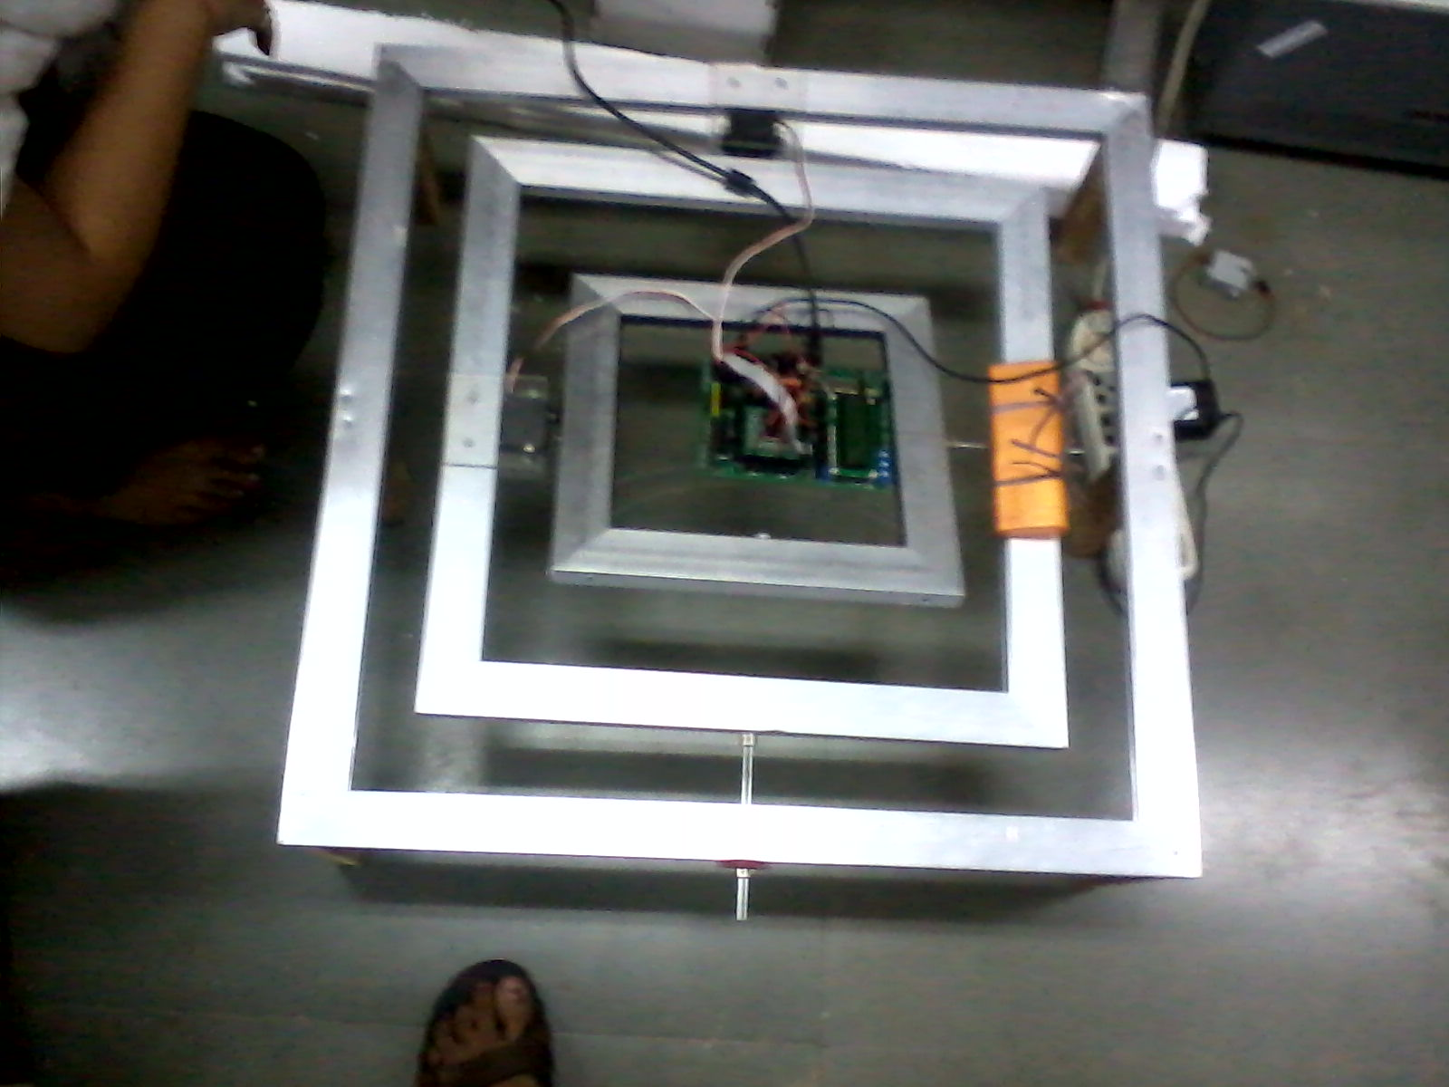

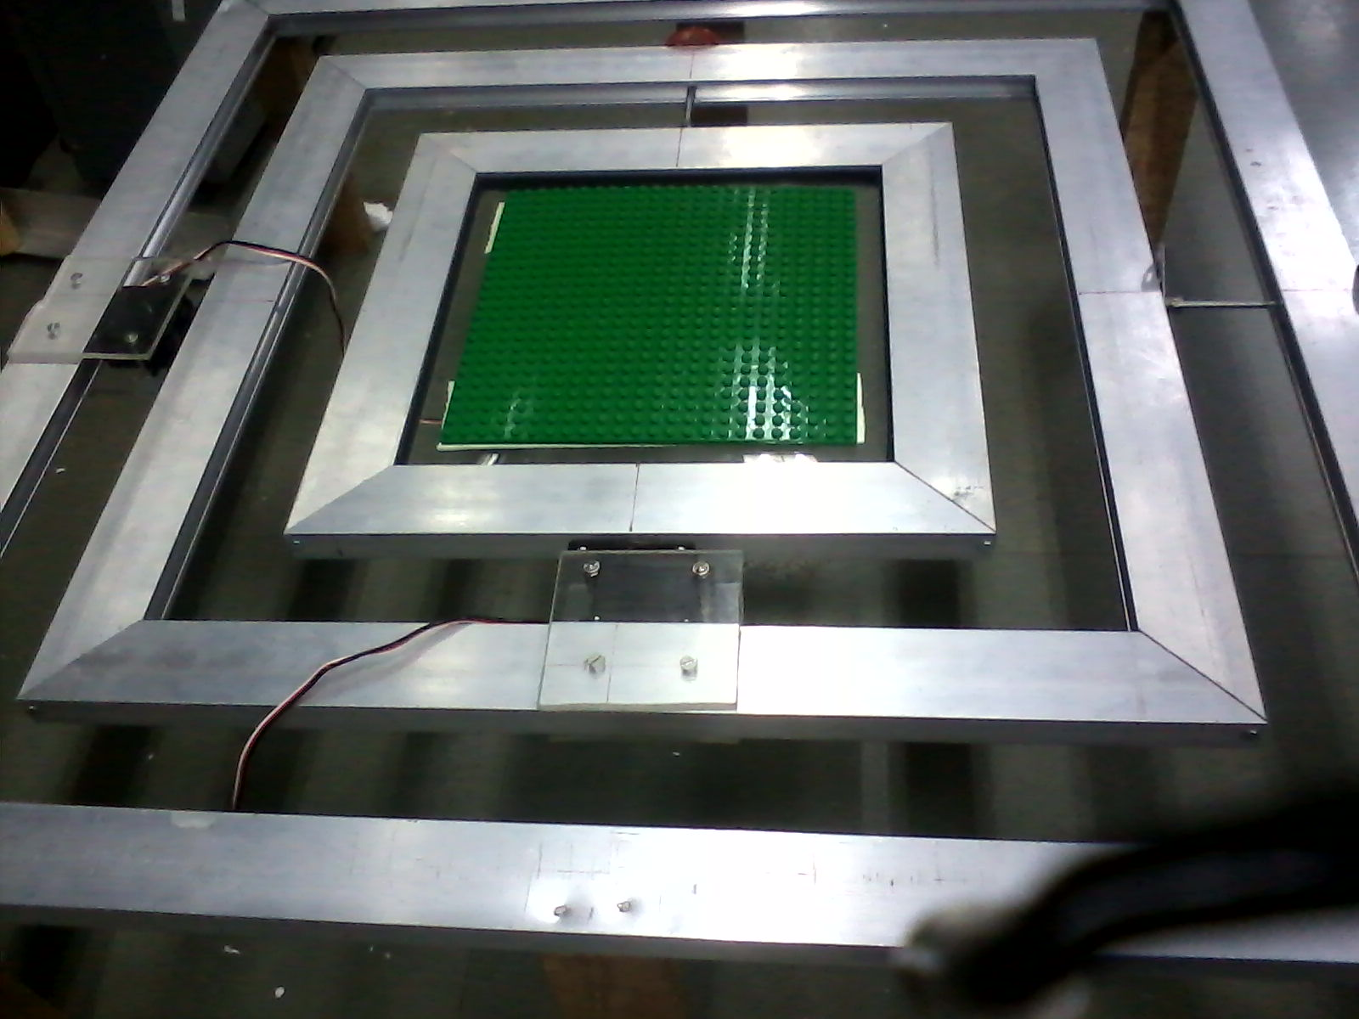

FURTHER WORK PLAN
Till 22nd December 2011, we are having our sem VII exam. So after that on 23rd December we will be connecting accelerometer to the frame structure and programming for the same.
Afterwards we will be mounting camera on frame structure and coding for the same by image processing with the help of MATLAB.

